IT Support
Architecture Document
Version 1.1
22/02/2024
Contents
1 Project planning 4
1.1 Eyes Worldcheck API 4
2 Service design 6
2.1 Service description 6
2.2 Resilience measures 7
2.3 Disaster recovery category 7
2.4 Backup policy 7
2.5 Security issues 7
2.6 Authentication and authorisation 8
2.7 External access 8
2.8 Interfaces and dependencies 9
3 Service specification 10
3.1 URLs, certificates and channels 10
3.2 Servers 12
3.3 Users, roles and groups 13
3.4 Firewall configuration 14
3.5 Scheduled tasks 15
3.6 Software licences 15
3.7 Configuration files 15
3.8 Patching 15
4 Disaster recovery plan 17

Version control
Date | Version | Author | Sections | Amendments
08/05/2023 | 1.0 |  | All | Initial draft.
22/02/2024 | 1.1 |  | All | Review
16/04/2024 | 1.1 | MB | All | Review

Project planning

Eyes Worldcheck API

Stakeholders
Role | Unit | Name
Technical Architect | IT Support
Peer Reviewer | IT Support
Project Manager | IT Support
Production Representative | Development | Blaison Damien

Summary of technical changes
Setting up a web API consumed by both BDO and external clients.

This project requires the following actions to be done:

External test environment
For user acceptance testing in a prod like approach (i.e. connecting as a client outside the BDO domain).

(New) A laptop not in BDO domain to act as an external client infrastructure. We’ll made a full install of EYES on it (desktop app, SQL server, scheduled task).
(New) IIS Web site on BDOLUX22-11.
(New) SQL instance “WorldCheck” on BDOLUX22-12.

FW/NTW new Rules:
- Laptop open to internet.
- API (EyesWorldcheck) on BDOLUX22-11 accessible from internet.
- API (EyesWorldcheck) on BDOLUX22-11 accessible from CFDOMAIN workstations.
- Laptop authorized to call APIs on BDOLUX22-11 (Token + EyesWorldcheck).
- Communication between APIs on BDOLUX22-11 (from EyesWorldcheck to Token).
- Communication from API (EyesWorldcheck) on BDOLUX22-11 to SQL server BDOLUX22-12\WorldCheck.

Test environment
(New) IIS Web site on BDOLUX19-13.
(New) Applicative server APPSRV.
(New) SQL instance “WorldCheck” on LUDB001.

FW/NTW new Rules:
- APIs (Token + EyesWorldcheck) on BDOLUX19-13 accessible from CFDOMAIN workstations.
- APIs (Token + EyesWorldcheck) on BDOLUX19-13 accessible from new APPSRV.
- HTTPS Request to WorldCheck authorized from new APPSRV.
- Communication from new APPSRV to SQL server LUDB001\WorldCheck.
- Communication from new APPSRV to SQL server LUDB001\EYES.
- Communication between APIs on BDOLUX19-13 (from EyesWorldcheck to Token).
- Communication from API (EYESWorldCheck) on BDOLUX19-13 to SQL server LUDB001\WorldCheck.

Production environment
We do not provide any server name in production – It’s up to Infra to decide whether existing server or new one should be used.

(New) IIS Web site (API-EYESWORLDCHECK).
(New) SQL server Instance SQLSRV\WORLDCHECK

FW/NTW new Rules:
- API (API-EYESWORLDCHECK) from internet.
- API (API-EYESWORLDCHECK) from CFDOMAIN workstations.
- API (API-EYESWORLDCHECK) from BDOLUXAPP02.
- API (token) from CFDOMAIN workstations.
- API (token) from BDOLUXAPP02.
- Communication between APIs (from API-EYESWORLDCHECK to Token).
- Communication from API (API-EYESWORLDCHECK) to SQL server SQLSRV\WORLDCHECK.
- Communication from BDOLUXAPP02 to SQL server SQLSRV\WORLDCHECK.

Service design

Service description
Each time an entity (company or individual) is created in EYES, it is screened against the data in World-Check database.
Every night, an automated process performs a full screening for all entities stored in EYES.

We have a partnership with Refinitiv in order to host their full World-Check database (refreshed every night) on our servers.
This database will have to be the reference for BDO and its clients meaning that the World-Check database will no more be provided to the client and that the screening will always be done on BDO servers.

To achieve it, a web REST API is built on BDO server to expose the data to both internal and external processes.

Key technologies
Technology | Version | New or existing
Back-End -> .net | .Net 8.0

Technical diagrams
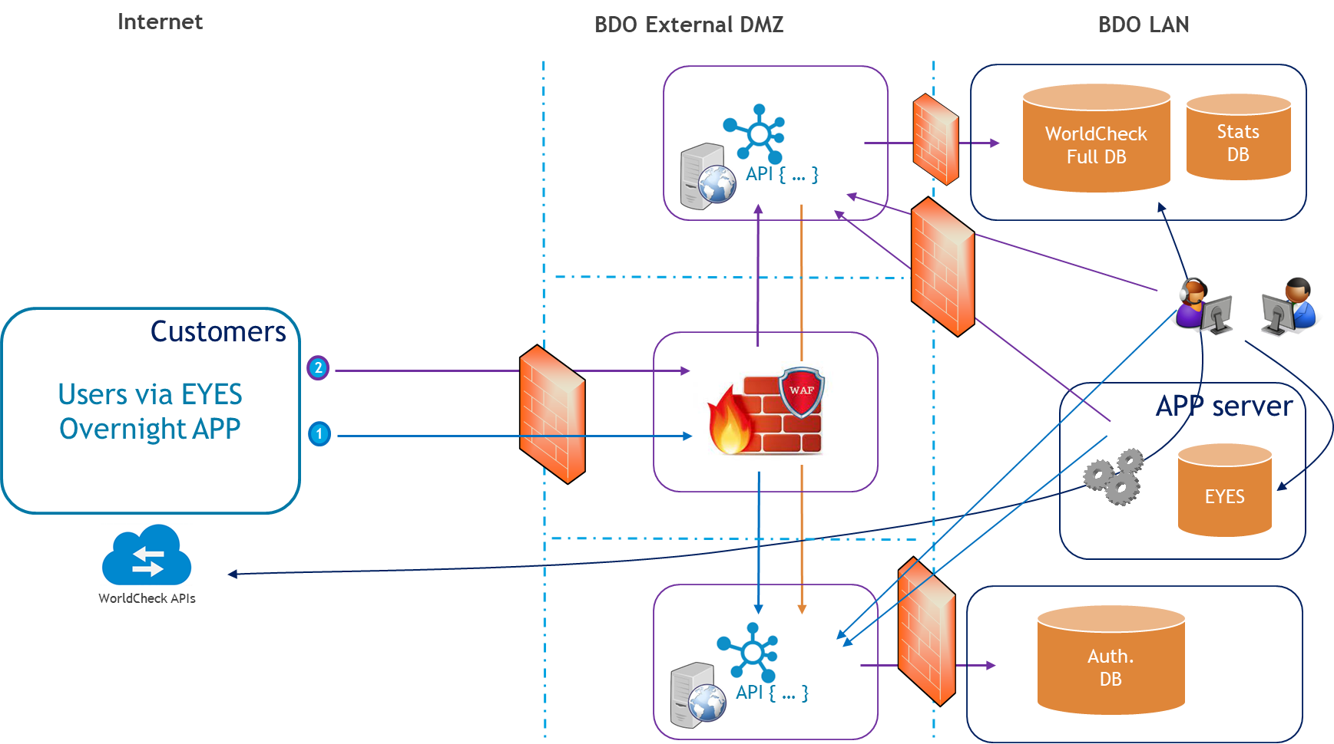

Resilience measures
RAS

Disaster recovery category

Application | Category
EYESWorldcheck | 3

Backup policy
Detail any variance from the currently agreed backup policy.
Component | Variance from backup policy
Operating System | None (standard backup)
Database | None (standard backup)
File system | None (standard backup)
Other | None (standard backup)

Security issues
The web API is opened to outside the BDO Domain
- Web server is located in a DMZ
- Server is protected by a Web application Firewall
- Only authorized extensions and Mime Type are accepted
- A valid https SSL certificate is deployed on IIS
- The access is only authorized via whitelisted URLs
- Request are validated against a token-based authentication (see 2.6)

Communication flow between web server, SQL server and internal applicative server are secured and limited.
The volume of data received and returned by the API via JSON file can be huge, a specific rule will be set-up at the WAF level to authorized such transfer.

The Microsoft Transparent Data Encryption (TDE) must be set-up to encrypt data and logs at rest on SQL server.
The connection to the SQL server is also encrypted to avoid clear network data transfer (valid dedicated SSL SQL server certificate must be applied).
With these two previous security rules implemented, IT-SEC confirms there is no need to encrypt the column data in SQL server.

The account used to connect the database will only be granted with the minimum required access rights.

GDPR: Data stored in the context of this new WorldCheck screening process are neither related to personal data nor related to the content of the request.
We are only storing data such as client ID, date and number of calls to the API… for statistical reason and further processing.
Nothing is changing about the data stored in EYES.

About the WorldCheck data………… public data collected by Refinitiv

Authentication and authorisation
The access to the API is done via desktop applications or automated technical tasks on servers so that an AD authentication with MFA is not possible.

Application will first call the TokenProvider to verify its identity and obtain a token of authentication.
Then the token is forwarded to the worldCheck API along with an API key (unique by client).
The API call could also be authenticated through the IP of the machine (large amount of Ips should be configured).

If ID is known and token is validated (well generated by TokenProvider, not expired, right caller…), we use the related client secret key to decrypt the body of the request.

The ID and key information are unique by client, generated randomly without sequence, and stored in the database using an AES 256 algorithm to encrypt them.

There is no specific applicative authorization, all request can access the same range of data.

External access
Name | Contact details | Access method | Description of need
SIMAC?

Infrastructure and deployment are under the responsibility of IT-INFRA and BDO Technology.
SIMAC as external partner could be involved?

Interfaces and dependencies
Describe any system interfaces to other corporate services and define their criticality, i.e. what would happen in the event of the interface becoming unavailable.
Would the interface be unavailable, the entities screening will be impossible leading to a potential breach in the acceptation or processing of client at risk.
This is impacting BDO but also external clients working with the EYES software.
If the unavailability is during the day, we’ll need to warn every “users” that the real-time screening will be bypass. The overnight should then be able to run in order to fill the gap.

Service specification

URLs, certificates and channels

Development (IDEs)
Application | URL
Front | N/A
Back | https://localhost:44372/api
Database | BDOLUX19-40\EYES

Test
Application | URL
Front | N/A
Back | https://bdolux19-40:xxx/api
Database | BDOLUX19-40\EYES

Internal Pre-Prod
Application | URL
Front | N/A
Back | https://bdolux19-13:448/EyesWorldcheck
Database | LUDB001\EYES  LUDB001\WORLDCHECK

External Pre-Prod
Application | URL
Front | N/A
Back | On bdolux22-11 https://BdoTechWorldcheckAPI-uat.bdo.lu:443
Database | BDOLUX22-12\WorldCheck

Prod
Application | URL
Front | N/A
Back | TBD
Database | TBD

MIME Type :
  - application/json
  - image/gif
  - image/jpeg
  - image/png
  - image/vnd.microsoft.icon
- text
  - text/css
  - text/html
  - text/plain

URLs :
https://bdolux19-12/econtact/CSS
https://bdolux19-12/econtact/assests/lib

List of extension

- .js
- .png
- .woff
- .woff2
- .jpeg
- .pdf
- .xls
- .xlsx
- .ttf
- .txt
- .ico
- .html
- .css
- .less
- .scss
- .json
- .yml
- .svg
- .eot
- .aspx
- .res
- .worker.js
- .js.mem
- .wasm
- .br.js.mem
- .gz.js.mem
- .min.js

Certificates
Certificate CN | CA | Server | Location

Servers

Application + web servers
 | Development/Test | Pre-prod | External test | Live
Servers | BDOLUX19-40 | New APPSRV +  BDOLUX19-13 | bdolux22-11 | BDOLUXAPP02 +TBD
Physical / Virtual
Shared / Dedicated
CPU cores
Memory
OS
Software and versions
Dependencies | e.g. SMTP

Database servers
 | Development/Test | Pre-prod | External test | Live
Server | BDOLUX19-40 | LUDB001 | BDOLUX22-12 | BDOLUXAPP02  + TBD
Physical / Virtual
Shared / Dedicated
CPU cores
Memory
OS
Instance | EYES | EYES WORLDCHECK | EYES WORLDCHECK | EYES  WORLDCHECK
Database version | MS SQL Server 2019 (RTM-CU8-GDR) Express Edition
Dependencies

File systems
Server names | Volume | Size | Purpose
 | e.g. F: | e.g. 50MB | e.g. logging

File shares
Server names | Shared path | Share name

Share name | Users / groups | Permissions

Users, roles and groups

Windows
Username | Description

Group Name | Members | Description

SQL Server
Database | Description

Login | Description

Database User | Database | Mapped roles

Linked server | Source database | Source user

Firewall configuration

Palo Alto firewall
Source | Destination | Port | Protocol

F5 firewall
Source | Destination | Port | Protocol

Windows firewall
Source | Destination | Port | Protocol

Scheduled tasks

Windows scheduled tasks
Server | Run as | Task name | Schedule | Description

SQL Server jobs
Server | Job name | Schedule | Description

Software licences
Software | Supplier | Requirements | Expires

Configuration files
Backend server

Configuration file with encrypted connection string to SQL Server.
Configuration file “appSetting.json” to SQL Server.
Location: TBD

For Pre-prod and Prod.

Patching
For applicative patching:
Sources are released in a dedicated folder on the network and can then be deployed (copy/paste) on the server.

Disaster recovery plan
Describe the steps that must be taken to recover the service in the event of a site loss.

